|  |  |
| --- | --- |
| **Course Tittle:** Physics Practical-6 | **Course Code: PHY** 322B |
| **Course Type:** Practical |



# Shahjalal University of Science and technology,Sylhet

**Department of Physics**

**LAB REPORT**

**Experiment NO: EL1**

**Experiment Name: (a)** Calibration of a cathode ray tube (CRT) for both AC and DC sources, **(b)** Measurement of an unknown frequency and **(c)** Determination of the phase angle between two AC sources using a CRT.

|  |  |
| --- | --- |
| **Submitted by** | **Submitted to** |
| **Name:**Md.AbuRaihan Khan  **Reg NO:**2020132046  **Session :**2020-21  **Course Roll:** IS-11-24  Department. of physics  SUST | **Name: Dr.Ahsan Habib**  **Assistant Professor**  **Department of CSE,sust** |

* **Abstract**

This study investigates the calibration procedure for a cathode ray tube (CRT) used in various electronic measurement applications, encompassing both AC and DC signal sources. The calibration process aims to establish a reliable and accurate relationship between the input signal and the observed deflection on the CRT screen.

For DC measurements, the calibration involves applying known DC voltages to the horizontal and vertical deflection plates while measuring the corresponding deflection distances on the screen. A linear relationship is typically expected, and the calibration factors (sensitivity) are determined by analyzing the slope of the deflection-voltage graph.

For AC measurements, the calibration procedure becomes more complex due to the dynamic nature of the signals. Techniques such as Lissajous figures, where the horizontal and vertical inputs are driven by sinusoidal signals with varying frequencies and phase relationships, are employed to determine the phase shift and amplitude of the input signals.

The calibration process ensures accurate measurements of voltage, frequency, phase, and other parameters using the CRT. This study highlights the critical aspects of CRT calibration, including minimizing external interference, maintaining stable operating conditions, and employing appropriate measurement techniques to achieve reliable and accurate results.

**Introduction:**

This experiment delves into the versatile applications of a Cathode Ray Oscilloscope (CRO), a fundamental instrument in electronics. We will explore its capabilities in:

**(a) Calibration for AC and DC Sources:** The CRO's accuracy hinges on proper calibration. This section will guide us through the process of calibrating the oscilloscope for both alternating current (AC) and direct current (DC) signals, ensuring precise measurements.

**(b) Measurement of an Unknown Frequency:** Leveraging the CRO's ability to display waveforms, we will determine the frequency of an unknown AC signal. This involves analyzing the waveform's characteristics and utilizing the oscilloscope's timebase settings.

**(c) Determination of the Phase Angle:**The CRO excels in visualizing phase relationships between signals.We will employ Lissajous figures – unique patterns formed on the screen when two sinusoidal signals are applied to the X and Y inputs – to accurately measure the phase difference between two AC sources.

* **Cathode Ray Oscilloscope:** The cathode ray oscilloscope is an electronic test instrument, it is utilized to get waveforms when the different information signals are given. It was originally known as an oscilloscope. The oscilloscope notices the progressions in the electrical signs over the long run, subsequently the voltage and time portray a shape and it is persistently graphed close to a scale. By seeing the waveform, we can break down certain properties like amplitude, frequency, rise time, time interval, distortion, etc.

The cathode ray oscilloscope is mainly worked on voltage and additionally other actual amounts like strain, current; pressure and speed increase are changed into the voltage utilizing the transducer and show on a CRO. This instrument incorporates an iridescent spot or pointer that turns on the showcase locale because of an information voltage. This pointer can be delivered through an electron bar that hits on a fluorescent display. Basically this test is used to perform the waveforms based on the input signals or in response to them. Electron beam and cathode ray tube is used to analyze the waveforms with the help of electrical circuits and thus it plays important role in electronic circuits.

The run of the mill type of the cathode ray oscilloscope utilizes a flat info voltage i.e. inside created incline voltage known as a period. The level voltage moves the pointer occasionally in a flat manner from the passed-on side to one side on the region of the screen. Here the upward voltage is only the voltage below investigation. This voltage moves the pointer up and down on the showcase. When the info voltage moves rapidly on the showcase, then, at that point, it seems idle. Hence, this oscilloscope furnishes the imagining voltage by changing with time.

**Objectives:**

1. To familiarize with cathode ray oscilloscope (CRO), signal generator, AC and DC power supplies,
2. To understand the calibration of CRT,
3. To evaluate the unknown frequency of the signal using Lissajous figure,
4. To find the phase angle between two AC sources.

**Theory:**

The CRO provides a two-dimensional visual display of the signal wave-shape on a screen thereby allowing a scientist to see the signal in various parts of the circuit. CRO is used to measure many electrical quantities such as AC and DC voltages, time, phase relationships, frequency, power factor, inductance of a coil and a wide range of waveform characteristics like rise-time, fall-time, etc. The CRO consists of the following major sub-systems:1.CRT-it displays the quantity to be measured, (2) vertical amplifier –it amplifies the signal waveform to be viewed, (3) horizontal amplifier-it is fed with saw-tooth voltage which is then applied to the X-plates, (4) sweep generator- it produces saw-tooth voltages waveform used for horizontal deflection of the electron beam, (5) trigger circuit- it produces trigger pulses to start horizontal sweep, (6) high and low voltage power supplies.

A CRT is the main part of the CRO. The major components of CRT are:

1. An electron gun- for producing a stream of electrons,
2. Focusing and accelerating anodes- for producing a narrow and sharply focused beam of electrons,
3. Horizontal and vertical deflection plates- for controlling the path of the beam
4. An evacuated glass envelope with a fluorescent screen- produces bright spot when struck by a high velocity electron beam.
5. In this experiment, one can measure the DC voltage needed to be applied across the vertical deflection plates for certain division deflection of the beam vertically. One can also determine the AC voltage similarly. In case of DC voltage, one can see the vertical spot on the screen, but in the case of AC voltage, one can see the vertical line on the screen and also one can see the waveform of the AC voltage by applying the saw-tooth voltages horizontally. To determine the unknown frequency of an AC voltage signal, apply the known and unknown AC signals to the vertical and horizontal deflection plates, respectively. The relation that can enable us to determine the unknown frequency of the AC signal is

$$\frac{unknown frequency of the AC signal applied to the horizontal plates\left(f_{hor_unknown}\right)}{known frequency of the AC signal applied to the vertical plates \left(f_{ver_known}\right)}$$

$=\frac{No of loops cut along the verticle line seen in the CRO \left(N_{loop_ver_line}\right)}{No of loops cut along the horizontal line seen in the CRO\left(N_{loop_hor_line}\right)}$.............................(1)

To understand the phase angle between two AC signals, we consider the mathematical form of these signals which are applied to the vertical and horizontal plates of CRT:

$$x=A\sin\left(ωt\right)……….\left(2\right)$$

And $y=B\sin\left(ωt\right)……….\left(3\right)$

where α is the phase angle between two AC signals.

From Eq. (2), sin $ωt$ = $\frac{x}{A}and hence \cos{ω}t=\sqrt{1-{\left(\frac{x}{A}\right)}^{2}}$.

$$or,\frac{y}{B}=\frac{x}{A}\cos{ω}t+\sqrt{1-{\left(\frac{x}{A}\right)}^{2}}sinα$$

$$or,\frac{y}{B}-\frac{x}{A}\cos{ω}t=\sqrt{1-{\left(\frac{x}{A}\right)}^{2}}sinα$$

$$or{\left(\frac{y}{B}-\frac{x}{A}\cos{ω}t\right)}^{2}={\left(\sqrt{1-{\left(\frac{x}{A}\right)}^{2}}sinα\right)}^{2}$$

$$or,{\left(\frac{y}{B}\right)}^{2}+{\left(\frac{x}{A}\right)}^{2}\cos^{2}{α}-2\frac{xy}{AB}cosα=\left\{1-{\left(\frac{x}{A}\right)}^{2}\right\}\sin^{2}{α}$$

$or,{\left(\frac{y}{B}\right)}^{2}+{\left(\frac{x}{A}\right)}^{2}-2\frac{xy}{AB}cosα=\sin^{2}{α}$......................(4)

This is the general equation of an ellipse.

Now we are required to find the expression for α. The resultant motion of the above signals (Eqs. (2) and (3)) can depict a picture of an ellipse, either obliquely or symmetrically depending on the value of the phase angle α.

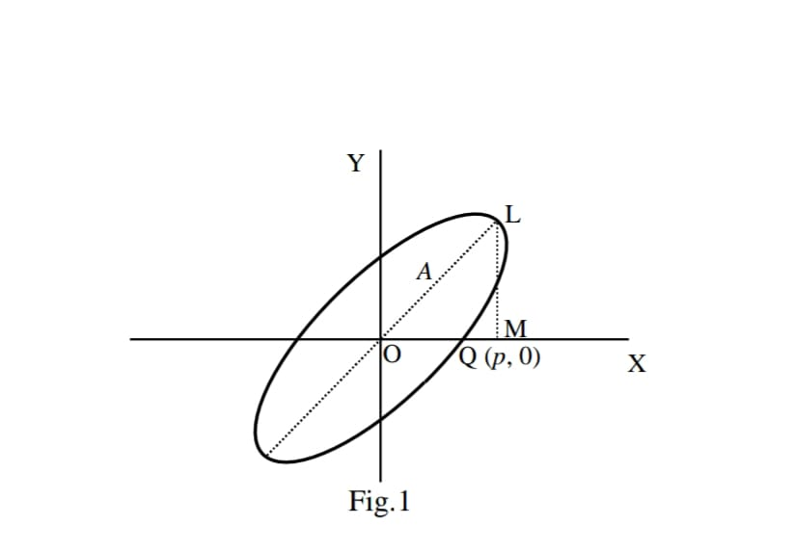

Fig.1

For the general ellipse shown in Fig.1, we have for the point Q (p, 0)

$${\left(\frac{P}{A}\right)}^{2}+0-0=\sin^{2}{α}$$

$or,α=\sin^{-1}\left(\frac{P}{A}\right)$.................(5)

Here p is the point on the X-axis cut by the ellipse and A is the length of the semi-major axis.

Therefore, equation (5) can be applied to determine the phase angle (phase difference) $α$ between two AC signals.

**Apparatus:**

1. Two signal generators,
2. CRO( Cathode Ray Oscilloscope)
3. DC and AC voltage sources,
4. voltmeters (AC and DC),
5. connecting wires etc

**Procedure:**

**Part (a): Calibration of a CRT for both AC and DC sources**

**1.DC Calibration:**

* Connect the output of the function generator to the Y-input of the CRO.
* Set the function generator to output a DC voltage.
* Adjust the DC voltage and observe the deflection of the electron beam on the screen.
* Note the deflection on the screen for different DC voltages.
* Plot a graph of deflection (in divisions) against DC voltage. This graph will serve as the calibration curve for DC measurements

2. **AC Calibration:**

* Set the function generator to output a sinusoidal waveform.
* Adjust the amplitude and frequency of the signal.
* Observe the waveform on the screen.
* Adjust the CRO's controls (time/div and volts/div) to obtain a stable and clear waveform.
* Measure the peak-to-peak amplitude of the waveform on the screen.
* Calculate the RMS voltage using the formula:
  + RMS voltage = (Peak-to-peak voltage) / (2 * √2)
* Repeat the above steps for different frequencies and amplitudes.
* Plot a graph of the measured RMS voltage against the known RMS voltage from the function generator. This graph will serve as the calibration curve for AC measurements.

**Part (b): Measurement of an unknown frequency**

1. Connect the output of the function generator to the Y-input of the CRO.
2. Set the function generator to output a sinusoidal waveform of unknown frequency.
3. Adjust the CRO's time/div control to display a stable waveform on the screen.
4. Count the number of cycles of the waveform that occur within a known time interval (e.g., 10 divisions on the time axis).
5. Calculate the time period of the waveform.
6. Determine the unknown frequency using the formula:
   * Frequency (f) = 1 / Time period (T)

**Part (c): Determination of the phase angle between two AC sources**

1. Connect the output of two function generators to the X and Y inputs of the CRO, respectively.
2. Set both function generators to output sinusoidal waveforms with the same frequency.
3. Adjust the amplitude and phase of the signals.
4. Observe the Lissajous figure on the screen.
5. Identify the type of Lissajous figure (e.g., circle, ellipse, line).
6. Determine the phase angle between the two signals based on the shape and orientation of the Lissajous figure.
   1. Refer to Lissajous figure tables or online resources to determine the phase angle.
7. Repeat the measurements for different phase angles.

**Table 1:** DC Voltage Calibration (plot div. vs Applied Voltage)

|  |  |  |
| --- | --- | --- |
| **No of obs.** | **Applied voltage** | **Applied voltage (div.)** |
|  | 01 | 3.50 |
|  | 02 | 7.50 |
|  | 03 | 12.00 |
|  | 04 | 15.00 |
|  | 05 | 19.00 |
|  | 06 | 22.00 |
|  | 07 | 25.00 |

**Table 2:** Ac voltage Calibration (plot div. Vs applied volt.)

|  |  |  |
| --- | --- | --- |
| **No of obs.** | **Applied voltage** | **Applied voltage (div.)** |
|  | 01 | 3.50 |
|  | 02 | 6.00 |
|  | 03 | 8.90 |
|  | 04 | 12.00 |
|  | 05 | 19.50 |
|  | 06 | 17.00 |
|  | 07 | 20.00 |

**Table 3:** Unknown frequency of the applied AC signal

|  |  |  |  |  |
| --- | --- | --- | --- | --- |
| No of obs. | $$f_{ver_{-}known\left(Hz\right)}$$ | $$N_{loop_{-}ver_{-}line}$$ | $$N_{loop_{-}hor_{-}line}$$ | $$f_{hor_{-}unknown}=\left(f_{ver_{-}known}\right)×\left(\frac{N_{loop_{-}ver_{-}line}}{N_{loop_{-}hor_{-}line}}\right)$$ |
|  | 100 | 1 | 1 | 100.00 |
|  | 200 | 1 | 2 | 100.00 |
|  | 300 | 1 | 3 | 101.67 |
|  | 400 | 1 | 4 | 102.50 |
|  | 500 | 1 | 5 | 102.00 |
|  | 600 | 1 | 6 | 103.34 |

**Table 4: phase Angle Measurement**

|  |  |  |  |  |  |  |  |  |  |  |  |  |
| --- | --- | --- | --- | --- | --- | --- | --- | --- | --- | --- | --- | --- |
| **No of obs** | **P=om**  **(div.)** | **(div.)** | **Pstd** | **ML**  **(div.)** | **(div.)** |  |  | **Astd** | **A= $\overline{A}$ +Astd** | $$\overline{α}$$ | $$α_{std}$$ | $$\overline{α}+α_{std}$$ |
| **1** | **7.5** | **7.34** | **0.153** | **14.9** | **14.9** | **0.100** | **16.6098** | **0.113** | **16.6 $±$**  **.113** | **26.22** | **.011** | **26.22 $$±$$**  **.011** |
| **2** | **7.3** | **15.0** |
| **3** | **7.2** | **14.8** |

**Graph Plot: Applied voltage (div.) vs Applied voltage (v) for AC Calibration**

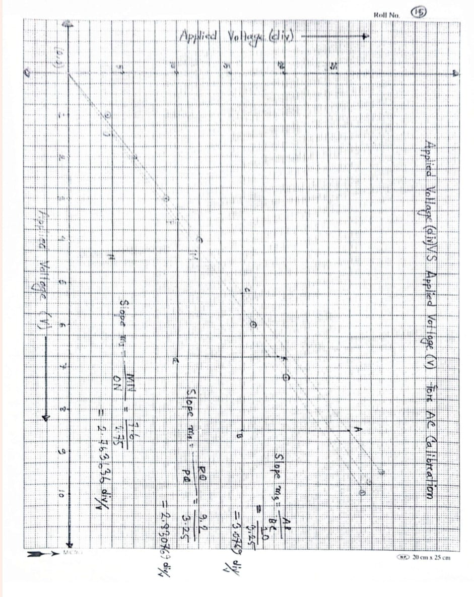

**Graph Plot: Applied voltage (div.) vs Applied voltage (v) for DC Calibration**

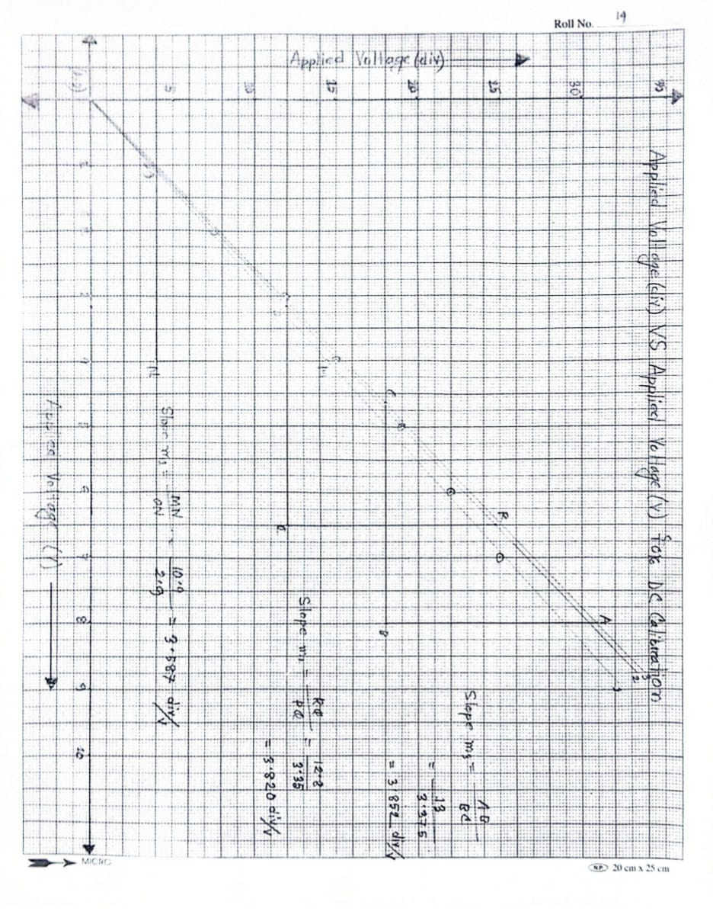

**Calculation:**

Phase angle calculation:

From Data table ,

For P=OM:

$$∴\overline{P}=\frac{p_{1}+p_{2}+p_{3}}{3}=7.34 div.$$

For ML=X:

$$∴\overline{x}=\frac{x_{1}+x_{2}+x_{3}}{3}=14.9 div.$$

For OL=A:

$$∴\overline{A}=\sqrt{{\left(\overline{P}\right)}^{2}+{\left(\overline{X}\right)}^{2}}=16.6098 div.$$

For phase Angle($α$):

$$∴\overline{α}=\sin^{-1}\left(\overline{\frac{P}{\overline{A}}}\right)={26.22}^{°}$$

**ERROR CALCULATION:**

**Error calculation of phase angle Measurement;**

**From data table;**

**Standard deviation of P=OM:**

$$P_{std}=\sqrt{\frac{{\left(\overline{P}-P_{1}\right)}^{2}+{\left(\overline{P}-P_{2}\right)}^{2}+{\left(\overline{P}-P_{3}\right)}^{3}}{3-1}}$$

=0.153

**Standard deviation of ML=x:**

$$X_{std}=\sqrt{\frac{{\left(\overline{x}-x_{1}\right)}^{2}+{\left(\overline{x}-x_{2}\right)}^{2}+{\left(\overline{x}-x_{3}\right)}^{3}}{3-1}}$$

=0.100

**Standard deviation of OL=A: $\left(σ_{f}\right)$**

Let

Where $f=\sqrt{{\overline{p}}^{2}+{\overline{x}}^{2}}≡\overline{A}σ_{p}=p_{std}$

$$σ_{x}=x_{std}$$

$$σ_{f}=\sqrt{{\left(\frac{δf}{δ\overline{p}}σ_{p}\right)}^{2}+{\left(\frac{δf}{δ\overline{x}}δ_{x}\right)}^{2}}$$

=0.113

**Standard deviation of phase angle ($α$): $\left(δ_{g}\right)$**

**Let $g=\sin^{-1}\left(\frac{\overline{P}}{\overline{A}}\right)$**

$$σ_{g}=\sqrt{{\left(\frac{δg}{δ\overline{p}}σ_{p}\right)}^{2}+{\left(\frac{δg}{δ\overline{A}}δ_{A}\right)}^{2}}$$

=0.011

**Standard deviation of unknown horizontal frequency ( $δf_{hor_{-}unknown})$:**

Let $f_{hor_{-}unknown}=f$

From data table (3)

$$∴\overline{f}=\frac{\overline{f_{1}}+\overline{f_{2}}+\overline{f_{3}}+\overline{f_{4}}+\overline{f_{5}}+\overline{f_{6}}}{6}$$

=101.585

**Standard deviation of unknown horizontal frequency:**

$$δf_{hor_{-}unknown}=\sqrt{\frac{{\left(\overline{f}-f_{1}\right)}^{2}+{\left(\overline{f}-f_{2}\right)}^{2}+{\left(\overline{f}-f_{3}\right)}^{2}+{\left(\overline{f}-f_{4}\right)}^{2}+{\left(\overline{f}-f_{5}\right)}^{2}+{\left(\overline{f}-f_{6}\right)}^{2}}{6-1}}$$

=1.352 Hz

**Result:**

**Phase angle between two AC sources**

$$α=\overline{α}+α_{std}=\left(26.220±0.011\right)°$$

**unknown horizontal frequency $\left(f_{hor_{-}unknown}\right)$:**

$$f_{hor_{-}unknown}={\overline{f}}_{hor_{-}unkmown}±{\overline{δf}}_{hor_{-}unkown}$$

$$=\left(101.585±1.352\right)Hz$$

**Conclusion:**

This experiment demonstrated the fundamental principles of using a Cathode Ray Tube (CRT) oscilloscope for various electrical measurements. Through careful calibration, we were able to accurately measure DC and AC voltages, determine the frequency of an unknown signal, and analyze the phase relationship between two AC sources.

**Findings:**

* **Calibration:** Proper calibration of the CRT is essential for accurate measurements. By establishing a known relationship between input signals and displayed waveforms, we minimized errors and ensured reliable results.
* **Frequency Measurement:** The oscilloscope's time base function allowed us to measure the period of an unknown signal, enabling the calculation of its frequency with reasonable accuracy.
* **Phase Angle Determination:** The Lissajous patterns observed on the CRT screen provided a visual representation of the phase difference between two AC signals. By analyzing these patterns, we were able to quantify the phase angle.

**Limitations:**

* **Accuracy:** The accuracy of the measurements is limited by the resolution of the CRT screen, the precision of the calibration process, and the stability of the signal sources.
* **Bandwidth:** The oscilloscope's bandwidth limits the highest frequency that can be accurately measured.
* **Probe Compensation:** Improper probe compensation can introduce errors in the measurements, especially at higher frequencies.